Assessment-4
Experiment 13:
AIM
Implementation of a simple calculator using LEX and YACC tools.

ALGORITHM
- Start the program.
- Create LEX file (calc.l) to identify tokens like numbers, operators (+, −, *, /, %, ^), and parentheses.
- Create YACC file (calc.y) to define grammar rules for expressions.
- In LEX, read input and convert numbers into double values.
- Pass tokens from LEX to YACC for parsing.
- In YACC, define precedence of operators and evaluation rules.
- Perform operations: addition, subtraction, multiplication, division, modulus (fmod), exponent (pow).
- Handle errors like division by zero and invalid input.
- Print result after evaluating each expression.
- Open terminal and navigate to program directory.
- Generate parser using: bison -d calc.y
- Generate lexer using: flex calc.l
- Compile using: gcc calc.tab.c lex.yy.c -o calc -lfl -lm
- Run program using: ./calc
- Enter expressions and view results.
- Stop execution using Ctrl + D.
SOURCE CODE
calc.l
/* calc.l - Lexer for simple calculator with modulus and exponentiation */
%{
#include <stdio.h>
#include <string.h>
#include "calc.tab.h" /* Include YACC-generated token definitions */

double num; /* Stores the numeric value */
%}

%%

[0-9]+(\.[0-9]+)? {
/* Match integers and decimals, convert to double */
num = atof(yytext);
yylval.dval = num;
return NUMBER;
}

"+" { return PLUS; } /* Addition operator */
"-" { return MINUS; } /* Subtraction operator */
"*" { return TIMES; } /* Multiplication operator */
"/" { return DIVIDE; } /* Division operator */
"%" { return MODULO; } /* Modulus operator */
"^" { return POWER; } /* Exponentiation operator */
"(" { return LPAREN; } /* Left parenthesis */
")" { return RPAREN; } /* Right parenthesis */
"\n" { return NEWLINE; } /* End of expression */

[ \t] ; /* Ignore spaces and tabs */

. {
/* Unknown character */
printf("Unknown character: %s\n", yytext);
}

%%

int yywrap() {
return 1; /* Signal end of input */
}

calc.y
/* calc.y - Parser for simple calculator with modulus and exponentiation */
%{
#include <stdio.h>
#include <stdlib.h>
#include <math.h> /* pow() for exponentiation, fmod() for modulus */

void yyerror(const char *msg);
int yylex();
%}

/* Define value type as double */
%union {
double dval;
}

/* Declare tokens from lexer */
%token <dval> NUMBER
%token PLUS MINUS TIMES DIVIDE MODULO POWER
%token LPAREN RPAREN NEWLINE

/* Declare result type for expressions */
%type <dval> expr term factor base

/* Operator precedence: lower listed = lower precedence */
%left PLUS MINUS /* Lowest precedence */
%left TIMES DIVIDE MODULO /* Same level as * and / */
%right POWER /* Right-assoc: 2^3^2=2^9 */
%right UMINUS /* Unary minus (highest) */

%%

/* --- Grammar Rules --- */

program:
/* empty */
| program line
;

line:
NEWLINE /* Blank line, do nothing */
| expr NEWLINE {
/* Print result after each complete expression */
printf("= %.6g\n", $1);
}
;

/* Addition and subtraction */
expr:
expr PLUS term { $$ = $1 + $3; }
| expr MINUS term { $$ = $1 - $3; }
| term { $$ = $1; }
;

/* Multiplication, division, and modulus */
term:
term TIMES factor { $$ = $1 * $3; }
| term DIVIDE factor {
/* Guard against division by zero */
if ($3 == 0) {
printf("Error: Division by zero\n");
$$ = 0;
} else {
$$ = $1 / $3;
}
}
| term MODULO factor {
/* Modulus: remainder after division */
if ($3 == 0) {
printf("Error: Modulo by zero\n");
$$ = 0;
} else {
$$ = fmod($1, $3); /* fmod works for doubles */
}
}
| factor { $$ = $1; }
;

/* Exponentiation (right-associative: 2^3^2 = 2^(3^2) = 512) */
factor:
base POWER factor { $$ = pow($1, $3); } /* Use math.h pow() */
| base { $$ = $1; }
;

/* Numbers, parenthesised sub-expressions, unary minus */
base:
NUMBER { $$ = $1; }
| LPAREN expr RPAREN { $$ = $2; }
| MINUS base %prec UMINUS { $$ = -$2; } /* Unary minus */
;

%%

/* --- Error handler --- */
void yyerror(const char *msg) {
fprintf(stderr, "Error: %s\n", msg);
}

int main() {
printf("Simple Calculator (LEX + YACC)\n");
printf("Operators: + - * / %% ^ and ( )\n");
printf(" %% = modulus (remainder) e.g. 10 %% 3 = 1\n");
printf(" ^ = power (exponent) e.g. 2 ^ 8 = 256\n");
printf("Press Ctrl+D to exit.\n\n");
yyparse(); /* Start parsing */
return 0;
}

OUTPUT
exam1@oslab-VirtualBox:~/Downloads/24/13$ bison -d calc.y & flex calc.l & gcc calc.tab.c lex.yy.c -o calc -lfl -lm
exam1@oslab-VirtualBox:~/Downloads/24/13$ ./calc

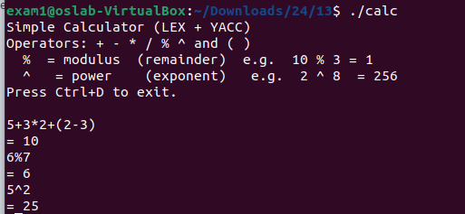
RESULT
A simple calculator was successfully implemented using LEX and YACC to evaluate arithmetic expressions with correct precedence.

Experiment 14:
AIM
Implementation of Abstract syntax tree –Infix to postfix using the LEX and YACC tools.

ALGORITHM
- Start the program.
- Create LEX file (ast.l) to identify tokens like numbers, operators (+, −, *, /, ^), and parentheses.
- Create YACC file (ast.y) to define grammar rules and AST structure.
- Read input infix expression using LEX.
- Convert numbers into double values and pass tokens to YACC.
- In YACC, construct AST nodes for numbers and operators.
- Apply operator precedence and associativity rules.
- Build AST using make_num() for operands and make_op() for operators.
- Traverse AST in inorder to display infix expression.
- Traverse AST in postorder to generate postfix expression.
- Display AST structure, infix, and postfix outputs.
- Open terminal and navigate to program directory.
- Run bison -d ast.y to generate parser files.
- Run flex ast.l to generate lexer file.
- Compile using gcc ast.tab.c lex.yy.c -o ast -lfl -lm.
- Execute using ./ast and enter expressions.
- Stop execution using Ctrl + D.
SOURCE CODE

ast.h
/* ast.h - Shared AST node definition included by both lexer and parser */
#ifndef AST_H
#define AST_H

typedef struct Node {
char op; /* Operator: + - * / ^ */
double val; /* Numeric value (leaves) */
int is_num; /* 1=leaf number, 0=operator */
struct Node *left; /* Left child */
struct Node *right; /* Right child */
} Node;

/* Constructor functions */
Node *make_num(double v);
Node *make_op(char op, Node *l, Node *r);

/* Traversal / display functions */
void print_infix(Node *n);
void print_postfix(Node *n);
void print_tree(Node *n, int depth);
void free_tree(Node *n);

#endif

ast.l
/* ast.l - Lexer for Infix to Postfix (AST) conversion */
%{
#include <stdio.h>
#include <stdlib.h>
#include "ast.h" /* AST node type used by parser */
#include "ast.tab.h" /* YACC-generated token definitions */
%}

%%

[0-9]+(\.[0-9]+)? {
/* Match integer or decimal number */
yylval.dval = atof(yytext);
return NUMBER;
}

"+" { return PLUS; } /* Addition */
"-" { return MINUS; } /* Subtraction */
"*" { return TIMES; } /* Multiplication */
"/" { return DIVIDE; } /* Division */
"^" { return POWER; } /* Exponentiation */
"(" { return LPAREN; } /* Open paren */
")" { return RPAREN; } /* Close paren */
"\n" { return NEWLINE; } /* End of expression */

[ \t] ; /* Skip spaces and tabs */

. {
/* Unrecognised character */
printf("Unknown token: %s\n", yytext);
}

%%

int yywrap() {
return 1; /* Signal end of input */
}

ast.y
/* ast.y - Parser to build AST and convert Infix to Postfix */
%{
#include <stdio.h>
#include <stdlib.h>
#include <string.h>
#include <math.h>

/* -------------------------------------------------------
AST Node Definition
Each node is either a leaf (number) or an operator
with left and right children.
------------------------------------------------------- */
typedef struct Node {
char op; /* Operator character: + - * / ^ */
double val; /* Number value (used for leaves) */
int is_num; /* 1 = leaf node, 0 = operator node */
struct Node *left; /* Left child */
struct Node *right; /* Right child */
} Node;

/* --- Function prototypes --- */
Node *make_num(double v);
Node *make_op(char op, Node *l, Node *r);
void print_infix(Node *n);
void print_postfix(Node *n);
void print_tree(Node *n, int depth, char *prefix, int is_left);
void free_tree(Node *n);
void yyerror(const char *msg);
int yylex();

/* -------------------------------------------------------
Create a leaf node storing a number
------------------------------------------------------- */
Node *make_num(double v) {
Node *n = (Node *)malloc(sizeof(Node));
n->op = '\0';
n->val = v;
n->is_num = 1;
n->left = NULL;
n->right = NULL;
return n;
}

/* -------------------------------------------------------
Create an operator node with two children
------------------------------------------------------- */
Node *make_op(char op, Node *l, Node *r) {
Node *n = (Node *)malloc(sizeof(Node));
n->op = op;
n->val = 0;
n->is_num = 0;
n->left = l;
n->right = r;
return n;
}

/* -------------------------------------------------------
Print expression in INFIX form (with parentheses)
------------------------------------------------------- */
void print_infix(Node *n) {
if (!n) return;
if (n->is_num) {
printf("%.6g", n->val);
} else {
printf("(");
print_infix(n->left);
printf(" %c ", n->op);
print_infix(n->right);
printf(")");
}
}

/* -------------------------------------------------------
Print expression in POSTFIX form
POST-ORDER traversal: left -> right -> operator
------------------------------------------------------- */
void print_postfix(Node *n) {
if (!n) return;
if (n->is_num) {
printf("%.6g ", n->val);
} else {
print_postfix(n->left);
print_postfix(n->right);
printf("%c ", n->op);
}
}

/* -------------------------------------------------------
Print AST top-to-bottom with branch lines

Example for 3 + 4 * 2 :

[ + ]
/ \
[3] [ * ]
/ \
[4] [2]

prefix = the indent string built up so far
is_left = 1 if this node is a left child, 0 if right
------------------------------------------------------- */
void print_tree(Node *n, int depth, char *prefix, int is_left) {
/* Buffer to build the next level's prefix string */
char new_prefix[512];

if (!n) return;

/* --- Print current node --- */
printf("%s", prefix);

if (depth == 0) {
/* Root node: no branch symbol */
printf(" "); /* centre indent for root */
} else {
/* Child node: show branch corner */
printf("%s", is_left ? "+--L-- " : "+--R-- ");
}

/* Print node label */
if (n->is_num)
printf("[%.4g]\n", n->val);
else
printf("[ %c ]\n", n->op);

/* --- If leaf, nothing more to do --- */
if (!n->left && !n->right) return;

/* --- Build prefix for children --- */
if (depth == 0) {
/* Children of root get a plain indent */
snprintf(new_prefix, sizeof(new_prefix), "%s ", prefix);
} else {
/* Extend prefix: if we were a left child, add a "|"
so the right sibling's lines connect properly */
snprintf(new_prefix, sizeof(new_prefix), "%s%s",
prefix,
is_left ? "| " : " ");
}

/* --- Print connector line between node and children --- */
printf("%s|\n", new_prefix);

/* --- Recurse into children --- */
if (n->left && n->right) {
/* Both children: print left first, then right */
print_tree(n->left, depth + 1, new_prefix, 1);
printf("%s|\n", new_prefix);
print_tree(n->right, depth + 1, new_prefix, 0);
} else if (n->left) {
print_tree(n->left, depth + 1, new_prefix, 1);
} else {
print_tree(n->right, depth + 1, new_prefix, 0);
}
}

/* -------------------------------------------------------
Free all dynamically allocated AST nodes
------------------------------------------------------- */
void free_tree(Node *n) {
if (!n) return;
free_tree(n->left);
free_tree(n->right);
free(n);
}
%}

/* YACC value type: either a double or an AST Node pointer */
%union {
double dval;
Node *node;
}

/* Token declarations */
%token <dval> NUMBER
%token PLUS MINUS TIMES DIVIDE POWER
%token LPAREN RPAREN NEWLINE

/* Non-terminal result types */
%type <node> expr term factor base

/* Operator precedence: lowest to highest */
%left PLUS MINUS
%left TIMES DIVIDE
%right POWER
%right UMINUS

%%

program:
/* empty */
| program line
;

line:
NEWLINE
| expr NEWLINE {
Node *tree = $1;

printf("\n+------------- AST (Top to Bottom) -------------+\n\n");
print_tree(tree, 0, "", 0); /* Start from root */

printf("\nInfix : ");
print_infix(tree);
printf("\n");

printf("Postfix : ");
print_postfix(tree);
printf("\n");
printf("+------------------------------------------------+\n\n");

free_tree(tree);
}
;

/* Addition and subtraction */
expr:
expr PLUS term { $$ = make_op('+', $1, $3); }
| expr MINUS term { $$ = make_op('-', $1, $3); }
| term { $$ = $1; }
;

/* Multiplication and division */
term:
term TIMES factor { $$ = make_op('*', $1, $3); }
| term DIVIDE factor { $$ = make_op('/', $1, $3); }
| factor { $$ = $1; }
;

/* Exponentiation - right-associative */
factor:
base POWER factor { $$ = make_op('^', $1, $3); }
| base { $$ = $1; }
;

/* Atoms: numbers, parentheses, unary minus */
base:
NUMBER { $$ = make_num($1); }
| LPAREN expr RPAREN { $$ = $2; }
| MINUS base %prec UMINUS {
$$ = make_op('-', make_num(0), $2);
}
;

%%

void yyerror(const char *msg) {
fprintf(stderr, "Parse error: %s\n", msg);
}

int main() {
printf("================================================\n");
printf(" Experiment 14: Infix to Postfix via AST \n");
printf(" (Using LEX and YACC Tools) \n");
printf("================================================\n");
printf("Enter an infix expression and press Enter.\n");
printf("Operators supported: + - * / ^ and ( )\n");
printf("Examples:\n");
printf(" 3 + 4 * 2\n");
printf(" (1 + 2) * (3 - 4)\n");
printf(" 2 ^ 3 ^ 2\n");
printf("Press Ctrl+D to quit.\n\n");

yyparse();
return 0;
}

OUTPUT
exam1@oslab-VirtualBox:~/Downloads/24/14$ bison -d ast.y && flex ast.l && gcc ast.tab.c lex.yy.c -o ast -lfl -lm
ast.y:171 parser name defined to default :"parse"
exam1@oslab-VirtualBox:~/Downloads/24/14$ ./ast

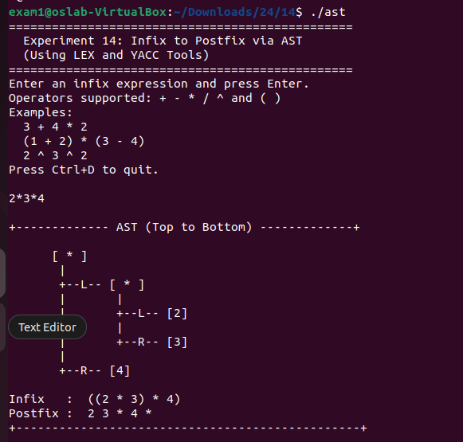

RESULT
An Abstract Syntax Tree was successfully constructed to convert infix expressions into postfix form using LEX and YACC.

Experiment 15:
AIM
Using LEX and YACC tools to recognize the strings of the following context-free languages:
- L(G) = { anbm / m ≠ n}
- L(G) = { ab (bbaa)n bba (ba)n / n ≥ 0}
ALGORITHM

- Start the program.
- Create LEX file to read characters ‘a’ and ‘b’.
- Count number of ‘a’ using a_count.
- Count number of ‘b’ using b_count.
- Pass tokens (TOK_A, TOK_B) to YACC parser.
- Define grammar: string → a_part b_part.
- Ensure structure is aⁿ followed by bᵐ only.
- After parsing, compare counts of a and b.
- If a_count ≠ b_count, accept the string.
- Else reject the string.
- Handle invalid characters and wrong patterns.
- Execution Steps:
1. Run bison -d lang1.y
2. Run flex lang1.l
3. Compile using gcc lang1.tab.c lex.yy.c -o lang1 -lfl
4. Execute using ./lang1 and give input.
SOURCE CODE
lang1.l
/* lang1.l - Lexer for L(G) = { a^n b^m | m != n }
Tokenises a sequence of 'a's and 'b's from a single line. */
%{
#include <stdio.h>
#include "lang1.tab.h" /* YACC token definitions */

int a_count = 0; /* Total 'a' characters seen */
int b_count = 0; /* Total 'b' characters seen */
%}

%%

"a" { a_count++; return TOK_A; } /* One 'a' character */
"b" { b_count++; return TOK_B; } /* One 'b' character */
"\n" { return NEWLINE; } /* End of input line */
[ \t] ; /* Skip whitespace */
. { return INVALID; } /* Any other char */

%%

int yywrap() { return 1; }

lang1.y
/* lang1.y - Parser for L(G) = { a^n b^m | m != n }

Grammar (CFG):
S -> A B (some a's followed by some b's, counts differ)
A -> a A | a (one or more a's)
B -> b B | b (one or more b's)

The grammar generates a*b* ; the inequality m != n is
checked semantically by comparing a_count and b_count
after the full string is parsed.
*/
%{
#include <stdio.h>
#include <stdlib.h>

extern int a_count; /* 'a' count from lexer */
extern int b_count; /* 'b' count from lexer */

void yyerror(const char *msg);
int yylex();
%}

/* Token declarations */
%token TOK_A TOK_B NEWLINE INVALID

%%

/* -------------------------------------------------------
Grammar Rules
------------------------------------------------------- */

program:
/* empty */
| program line
;

line:
NEWLINE /* blank line - skip */
| string NEWLINE {
/* Semantic check: accept only when m != n */
if (a_count != b_count) {
printf("String ACCEPTED (a^%d b^%d, %d != %d) => belongs to L(G)\n",
a_count, b_count, a_count, b_count);
} else {
printf("String REJECTED (a^%d b^%d, counts are equal) => NOT in L(G)\n",
a_count, b_count);
}
/* Reset counters for the next input line */
a_count = 0;
b_count = 0;
}
| INVALID NEWLINE {
printf("String REJECTED (invalid character encountered)\n");
a_count = 0;
b_count = 0;
}
;

/* A valid string is one or more a's followed by one or more b's */
string:
a_part b_part
;

/* One or more 'a' tokens */
a_part:
TOK_A
| a_part TOK_A
;

/* One or more 'b' tokens */
b_part:
TOK_B
| b_part TOK_B
;

%%

void yyerror(const char *msg) {
/* Reset on parse error (wrong structure like "bba") */
printf("String REJECTED (parse error - wrong structure: %s)\n", msg);
a_count = 0;
b_count = 0;
}

int main() {
printf("======================================================\n");
printf(" Experiment 15 - Language 1 \n");
printf(" L(G) = { a^n b^m | m != n } \n");
printf("======================================================\n");
printf("Enter a string of a's and b's, then press Enter.\n");
printf("Examples: ab aab abb aabb aaab\n");
printf("Press Ctrl+D to quit.\n\n");
yyparse();
return 0;
}

bison -d lang1.y && flex lang1.l && gcc lang1.tab.c lex.yy.c -o lang1 -lfl
./lang1

OUTPUT
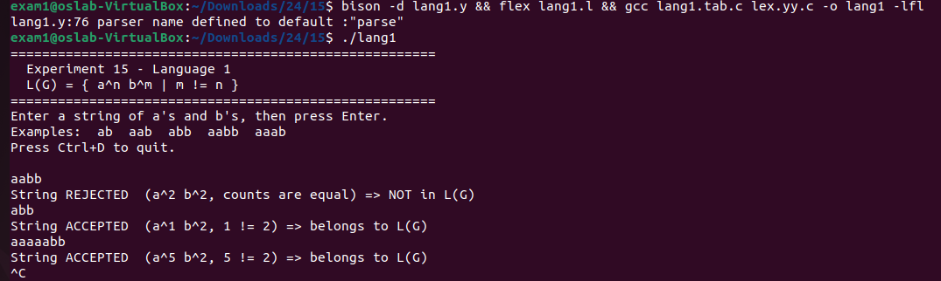

ALGORITHM
- Start the program.
- Create LEX file to tokenize ‘a’ and ‘b’.
- Pass tokens to YACC parser.
- Define grammar starting with prefix ab.
- Use recursive rule to match (bbaa)ⁿ.
- Ensure fixed middle pattern bba.
- Match `(ba)ⁿ using recursion.
- Maintain equal pairing of (bbaa) and (ba).
- If full pattern matches, mark string as accepted.
- Else reject the string.
- Handle invalid characters and parsing errors.
- Execution Steps:
1. Run bison -d lang2.y
2. Run flex lang2.l
3. Compile using gcc lang2.tab.c lex.yy.c -o lang2 -lfl
4. Execute using ./lang2 and give input.
SOURCE CODE

lang2.l
/* lang2.l - Lexer for L(G) = { ab(bbaa)^n bba(ba)^n | n >= 0 }

The alphabet is {a, b}. We tokenise each individual
character so the parser can match the exact pattern. */
%{
#include <stdio.h>
#include "lang2.tab.h" /* YACC token definitions */
%}

%%

"a" { return TOK_A; } /* Single 'a' character */
"b" { return TOK_B; } /* Single 'b' character */
"\n" { return NEWLINE; } /* End of input line */
[ \t] ; /* Skip whitespace */
. { return INVALID; } /* Unrecognised char */

%%

int yywrap() { return 1; }

lang2.y
/* lang2.y - Parser for L(G) = { ab(bbaa)^n bba(ba)^n | n >= 0 }

Pattern breakdown:
Fixed prefix : a b
Middle repeat : (b b a a)^n -- repeated n times
Fixed middle : b b a
End repeat : (b a)^n -- repeated same n times

Grammar (CFG):
S -> a b M (full string)
M -> bbaa M ba | bba (matched recursion for n >= 0)

The key insight: each "bbaa" on the left must be balanced
by exactly one "ba" on the right. The recursive rule M
enforces this pairing structurally.
*/
%{
#include <stdio.h>
#include <stdlib.h>

void yyerror(const char *msg);
int yylex();

int accepted = 0; /* Flag: 1 if string matched, 0 if not */
%}

/* Token declarations */
%token TOK_A TOK_B NEWLINE INVALID

%%

/* -------------------------------------------------------
Grammar Rules
------------------------------------------------------- */

program:
/* empty */
| program line
;

line:
NEWLINE /* blank line - skip */
| string NEWLINE {
if (accepted)
printf("String ACCEPTED => belongs to L(G)\n");
else
printf("String REJECTED => NOT in L(G)\n");
accepted = 0;
}
| INVALID NEWLINE {
printf("String REJECTED (invalid character)\n");
}
;

/* The full string must match: a b M */
string:
TOK_A TOK_B mid { accepted = 1; }
;

/* M -> bbaa M ba (one more (bbaa ... ba) pair added)
M -> bba (base case: n=0 contributes just "bba") */
mid:
TOK_B TOK_B TOK_A TOK_A mid TOK_B TOK_A
/* bbaa [recursive mid] ba -- adds one pair each side */
| TOK_B TOK_B TOK_A
/* bba -- innermost/base, contributes the fixed middle */
;

%%

void yyerror(const char *msg) {
/* Parse failure = string not in language */
printf("String REJECTED (does not match pattern: %s)\n", msg);
accepted = 0;
}

int main() {
printf("=================================================================\n");
printf(" Experiment 15 - Language 2 \n");
printf(" L(G) = { ab(bbaa)^n bba(ba)^n | n >= 0 } \n");
printf("=================================================================\n");
printf("Pattern: ab [bbaa]^n bba [ba]^n\n\n");
printf("Expected strings:\n");
printf(" n=0 : ab bba => abbba\n");
printf(" n=1 : ab bbaa bba ba => abbbaaббаба (abbbaabbaba)\n");
printf(" n=2 : ab bbaa bbaa bba ba ba\n\n");
printf("Enter a string and press Enter. Press Ctrl+D to quit.\n\n");
yyparse();
return 0;
}

bison -d lang2.y && flex lang2.l && gcc lang2.tab.c lex.yy.c -o lang2 -lfl
./lang2

OUTPUT
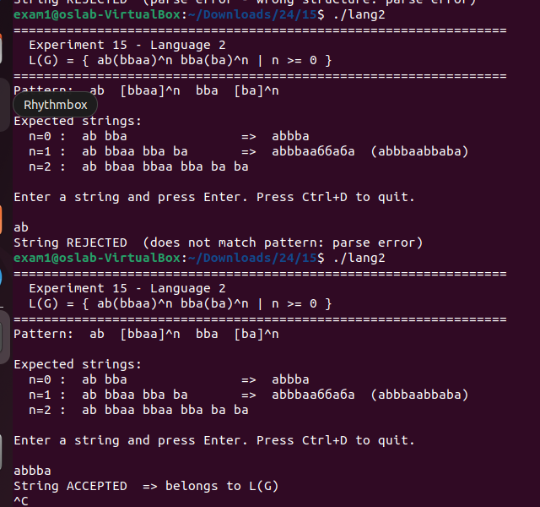

RESULT
The given context-free languages were successfully recognized using LEX and YACC tools.

